BSN SPECIFIC HANDBOOK

ASSOCIATE IN SCIENCE DEGREE-REGISTERED NURSE TO BACHELOR OF SCIENCE IN NURSING PROGRAM

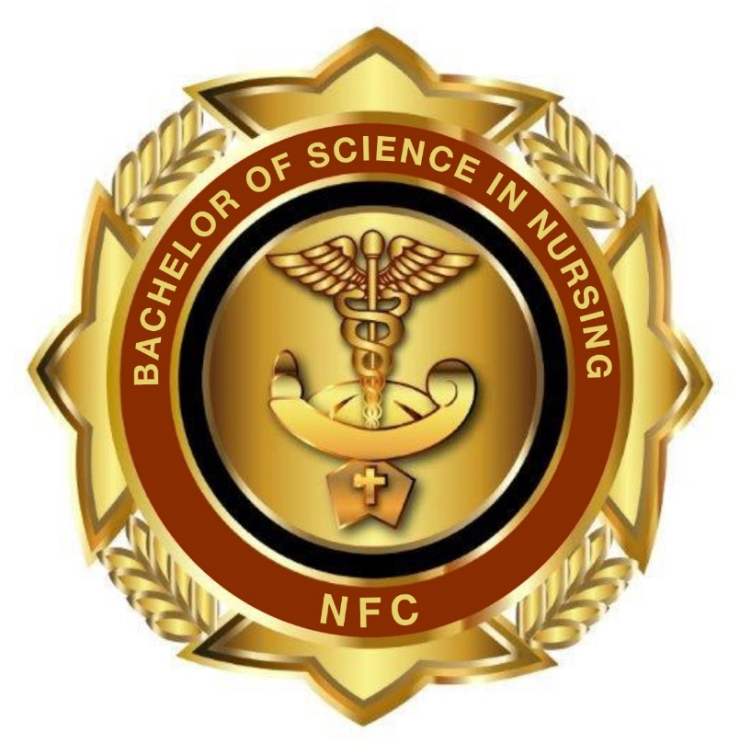

NORTH FLORIDA COLLEGE
Department of Nursing & Allied Health
325 NW Turner Davis Drive, Building 13 | Madison, Florida 32340

Welcome

Dear Nursing Students,

Welcome to North Florida College (NFC) Department of Nursing & Allied Health. We are pleased that you have chosen NFC as the educational institution to assist you in meeting your professional nursing career goals. Nursing is a journey of life-long learning, and our administration, faculty and staff look forward to assisting you in your educational process.

This nursing student handbook is designed to provide the post licensure RN-BSN nursing student with information about requirements, professional codes of conduct, policies, procedures, and guidelines specific to the Department of Nursing & Allied Health. It should be used as a supplement to the North Florida College Catalog, and the North Florida College Student Handbook. As adult learners within the scope of a professional education program, it is each student’s responsibility to locate and adhere to all established policies and procedures as presented by the Department of Nursing & Allied Health and North Florida College.

You are required to review the student handbook at the beginning of each semester so that you will be thoroughly familiar with all requirements of the program. As new policies and/or procedures are developed and incorporated into use, they will be provided and reviewed with you by NFC RN-BSN faculty. This handbook is included in the online RN-BSN orientation on the D2L learning system. Upon acceptance into the RN-BSN program you are enrolled and have access to the online orientation for completion. This online orientation should be completed prior to the first day of class.

Successful completion of this program requires your time, dedication, and effort. It is expected that you are self-directed, self-disciplined and that you accept responsibility for your own learning as this is an online program with experiential clinical learning activities completed in your place of employment and/or community in which you reside. Therefore, communication, excellent time management, study skills, motivation, maturity, and a strong sense of personal responsibility are necessary.

Thank you for choosing the NFC Department of Nursing & Allied Health for your continued nursing educational program. We have an excellent and experienced faculty who look forward to meeting you online very soon.

I wish you much success,

Dr. Anna Hall Kelley, DNP, APRN, WHNP-BC
Director, NFC Department of Nursing & Allied Health

DISCLAIMER

This handbook provides a summary of important information for students enrolled in the RN-BSN program. This handbook is to be used in conjunction with the NFC College Catalog and the NFC Student Handbook. The reader should note:

- It is not the intention of this handbook to address every policy, procedure, regulation or rule that may be applicable to students enrolled in Nursing and Allied Health programs.

- NFC and the Nursing and Allied Health Department reserve the right to change the contents of this handbook and/or supplements to this handbook at any time.

- It is the student’s responsibility to meet all program and graduation requirements. Our Nursing Advisor, Ms. Shante’ Fagin, will assist students in the planning of his/her program of study including the decision to select a full-time or part-time completion option; however, the final responsibility for fulfilling all program and graduation requirements rests with each student.

- When a student registers at NFC, the student is obligated to accept the rules and regulations of the College, which may be subject to change. Failure to abide by the Handbook policies may result in program dismissal. The Nursing and Nursing and Allied Health programs operate under the following guidelines:
  - NFC policies and procedures
  - NFC Student Handbook
  - NFC BSN Specific Handbook
  - Nursing and Allied Health policies and procedures
  - Nursing and Allied Health program student handbook
  - State and Federal Laws, Rules, and Regulations

Table of Contents
SECTION 1: DEPARTMENT OF NURSING & ALLIED HEALTH OVERVIEW 3
Mission, Vision, and Philosophy Statements 6
Betty Neuman’s Theory System Model 11
BSN Program Learning Outcomes 12
SECTION 2: PROGRAM CURRICULUM...............................................................................14
General Education Courses .........................................................................................................15
Program Curriculum 14
Important Email Addresses and Phone Numbers ......................................................................16
BSN Program Plan...................................................................................................................................17
SECTION 3: GENERAL ACADEMIC POLICIES & PROCEDURES 18
Academic Policies & Procedures 18
Chain of Command 21

SECTION 1

DEPARTMENT OF NURSING & ALLIED HEALTH OVERVIEW

Department of Nursing & Allied Health Mission Statement

Our mission is to meet the community healthcare career needs through facilitation of student enrollment and progression through healthcare programs with a student-centered learning environment that promotes student success through flexible and varied learning activities that foster creativity, critical thinking, and professional growth

Department of Nursing & Allied Health Vision Statement

NFC’s vision is to be the first choice for education and cultural enrichment for those in its surrounding communities. NFC is an exceptional college dedicated to an individualized and supportive academic atmosphere, accessible education, lifelong learning opportunities, and professional growth for our students and communities.

Department of Nursing & Allied Health Philosophy Statement

The philosophy of the North Florida College (NFC) Nursing and Allied Health Programs is consistent with the mission statement and objectives of NFC.

NFC is accountable in its offerings of quality, accessible and affordable learning opportunities and fulfills its mission through:

- Transferable college credit programs leading to the Associate of Arts Degree
- Workforce development programs leading to the Associate in Science Degree or technical certificates for occupational skills and employment
- Access to baccalaureate degree program through partnerships with colleges and universities
- Basic literacy and academic development opportunities through credit and non-credit programs
- Partnerships with business, industry, government, and other institutions to promote economic development and provide retraining opportunities for the districts workforce
- Support services to assist students in making educational, vocational and personal decisions
- Cultural, recreational and enrichment opportunities for students and residents of the community.

The philosophy and purposes of the Nursing Programs are developed by the nursing faculty. These statements of belief include:

- Concept of person
- Concept of environment
- Concept of health/wellness
- Concept of nursing
- Concept of teaching/learning
- Concept of nursing education
- Scope of nursing practice

Concept of Person

We believe the individual person is of central importance, has inherent dignity, and is worthy of respect and care. The individual person being has the freedom of choice and is accountable for those choices. The individual person has basic needs that are satisfied by infinitely variable patterns of growth and development. Congruent with Neuman’s Model of Nursing (Neuman & Fawcett, 2002), the client or client system may be the individual person, a family, group, community or social issue. This client system is open, holistic, and constantly trying to maintain system stability despite disruptive forces (stressors) acting upon the system. The client system behaviors and response to stress are the result of inter-relationships between an individual’s psychological, physiological, developmental, socio-cultural, emotional, and spiritual domains. These six client system domains or variables are found within the basic structure or core, the flexible and normal lines of defense, and the lines of resistance. These layers function as protective mechanisms for the basic structure so that client system integrity is maintained.

Concept of Environment

We believe the environment is also an open system and consists of all the internal and external forces and factors surrounding the client system. The client system is in constant interaction with the environment; thus, the environment influences the system and is influenced by the system. Stressors are part of the internal (within the client system) and external (outside the client system) environment and their influence on the client system can be positive or negative. According to Neuman (p. 19), a third environment called the creative environment is an open system exchanging energy with both internal and external environments. It is symbolic of wholeness and its function is to help maintain system integrity either consciously, unconsciously, or both.

Concept of Health & Wellness

We believe that health and wellness is a dynamic composite of the client system’s physiologic, psychological, socio-cultural, developmental, emotional and spiritual inter-relationships that enable an individual to resist or adapt to stressors which enable the individual to meet their needs, conserve energy and move toward wellness. That is, optimal wellness is a state where all needs are met, and more energy is stored than expended. When the individual cannot adapt/adjust to stressors in the environment or adjust/adapt the environment to the individual, energy is expended, needs are unmet and there is a movement toward illness.

Concept of Nursing

We believe that nursing is primarily concerned with human life, the quality of life, and the quality of health of the client system. Nursing is the process of assisting the client system as the client moves toward optimal wellness level or a peaceful death. Nursing functions are viewed as complex and creative, offering infinite opportunity for the application of the physical, biological and social sciences and the development of the skills based upon them. In keeping with Neuman’s model (p 25), nursing activities are initiated to best retain, attain, and maintain optimal client system stability for optimal health and wellness. The nurse uses the nursing process to assess for environmental stressors and plans interventions at the primary, secondary and tertiary levels that will assist the client system to maintain stability. Thus, the goal for nursing is a stable client system which creates linkages among the client, the environment, health and nursing.

Concept of Teaching & Learning

Teaching is the art and science of structuring content (information and processes) for student learning. We believe it involves the incorporation of a variety of teaching strategies designed to meet the diverse learning styles and needs of the student. As a facilitator of learning, the teacher creates an environment that promotes motivation and guides the student in learning. The teacher plans/directs learning activities that enhance the development of skills in critical thinking, decision-making and creativity. Additionally, the facilitator models the role of the professional nurse. Learning is viewed as a lifelong process whereby changes in thought and behavior occur through the attainment of cognitive, psychomotor and affective skills. The learning process is facilitated by humans’ inherent creative drive toward higher and more positive levels of existence. The learner is invited to apply this creative drive through active participation in the learning process. Positive feedback and learner success builds confidence and facilitates the development of positive attitudes and an eagerness to learn more.

Concept of Nursing Education

Nursing education at NFC is based upon principles derived from nursing, the humanities, behavior, math, and biophysical and social sciences. We believe these principles are intrinsically related and from these principles the student will assimilate and apply knowledge to the care of client systems.

This application of theory will take place in a simulated laboratory as well as in a variety of planned clinical experiences where the student will be able to demonstrate the progressive acquisition of skills, attitudes, critical thinking and decision-making abilities.

We believe that learning involves the use of previously acquired knowledge and experience. Therefore, we believe nursing education need not be an obstacle course whereby one type of program discounts another in such a way that students are forced to repeat content learned in previous academic pursuits. Common course descriptions, numbering systems and core competencies facilitate the progress of nursing students as they advance in professional rank without undue redundancy and without jeopardizing the quality of education or the skills of the graduates.

The RN-BSN Program at North Florida College is committed to three areas of responsibility for nursing education:

- The production of a professional post-licensure nurse who is prepared to care for a variety of clients, the family and the community within the framework of baccalaureate degree education.
- The upgrading of the post-licensure associate nurse to the baccalaureate level through carefully planned articulation with college/university programs; and
- The application of evidence-based research into professional nursing practice.

Concept of Scope of Practice

The professional nursing standards, guidelines, and/or competencies are based on using:
- The American Association of Colleges of Nursing (AACN) Essentials of Baccalaureate Education for Professional Nursing Practice (2021).
- National League for Nursing Educational Competencies: Human Flourishing, Nursing Judgment, Professional Identity, and Spirit of Inquiry. (2022) http://www.nln.org
- Florida Department of Education Curriculum Frameworks 2022-2023
- Florida Department of Health Board of Nursing (2022)
- American Nursing Association Scope and Standards of Practice (2021)
- Quality and Safety Education for Nurses (QSEN) (2022) www.qsen.org

Graphic Representation of the Department of Nursing & Allied Health
Betty Neuman’s Nursing Theory System Model

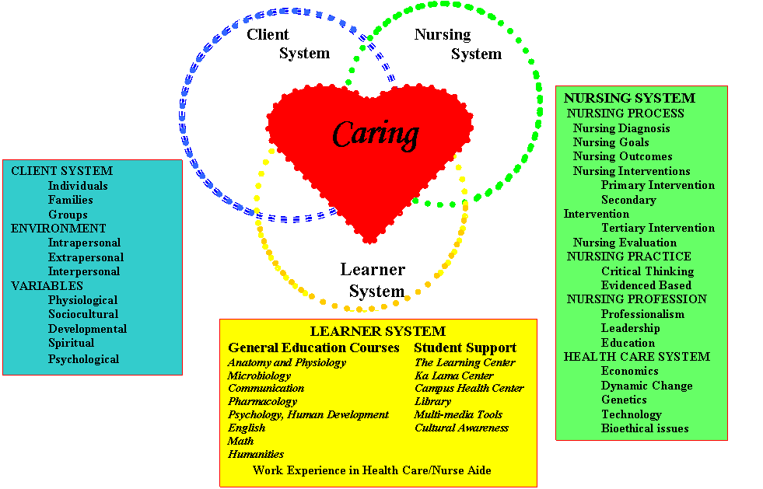

Associate in Science Degree-Registered Nurse to Bachelor of Science in Nursing

Program Student Learning Outcomes

The Associate in Science Degree-Registered Nurse to Bachelor of Science in Nursing Program at NFC will prepare graduates to:

- Demonstrate an understanding of nursing’s distinct and shared perspectives through the application of theory and research-based knowledge from nursing, the arts, humanities, and other sciences (Essential Domain 1; QSEN 3).

- Investigate strategies to advance equitable, safe, effective, and efficient patient-
/community-focused care, including partnerships and advocacy (Essential Domains 2, 3).

- Demonstrate an understanding of scholarly nursing practice by integrating best evidence into practice and promoting ethical conduct in scholarly activities to advance the scholarship of nursing (Essential Domain 4; QSEN 3).

- Analyze standardized, evidence-based processes for care delivery and apply quality improvement principles to care delivery to contribute to a culture of patient safety (Essential Domain 5; QSEN 4, 5).

- Use knowledge of nursing and other professions to address healthcare needs by communicating in a manner that facilitates a partnership approach to quality care delivery (Essential Domain 6; QSEN 2).

- Effectively and proactively coordinate resources to provide safe, quality, and equitable care to diverse populations through the application of innovation and evidence-based practice (Essential Domains 2,7).

- Use information and communication technology to gather data, create information, and generate knowledge to support the delivery of safe person-centered care to diverse populations in a variety of settings (Essential Domains 2, 8; QSEN 1,6).

- Contribute to the professional identity of nursing by demonstrating accountability to individuals, society, and the profession through ethical practice and compliance with laws, policies, and regulations (Essential Domain 9)
.
- Develop leadership proficiency to enhance advocacy for patients and the nursing profession (Essential Domain10)
The outcomes are consistent with the American Association of Colleges of Nursing Essential of Baccalaureate Education for Professional Nursing Practice.

References

American Association of Colleges of Nursing [AACN], 2021. The essentials of baccalaureate education for professional nursing practice. Retrieved from
https://www.aacnnursing.org/Portals/42/AcademicNursing/pdf/Essentials-2021.pdf

American Nurses Association. (2021). Nursing: Scope and Standards of Practice. Silver Spring, Maryland: nursesbook.org (4th ed.).

Neuman, B., & Fawcett, J. (2002). The Neuman Systems Model. (4th ed.). Upper Saddle River, New Jersey: Prentice Hall.

Pew Health Professions Commission. (1998). Recreating health professional practice for a new century. The Center for Health Professions at the University of California.

National League for Nursing. (2022). http://www.nln.org/

Quality and Safety Education for Nurses. www.qsen.org

SECTION 2: PROGRAM CURRICULUM

General Education Courses
Communication | Freshman English I | ENC 1101 | 3 Credits
 | Freshman English II | ENC 1102 | 3 Credits
Social Sciences | General Psychology | PSY 2012 | 3 Credits
 | Human Development | DEP 2004 | 3 Credits
Physical Sciences | Human Anatomy & Physiology I | BSC 2085C | 4 Credits
 | Human Anatomy & Physiology II | BSC 2086C | 4 Credits
 | Microbiology | MCB 2010C | 4 Credits
 | Fundamentals of Human Nutrition | HUN 2201 | 3 Credits
 | Survey of Chemistry or  General Chemistry I - with Lab or one course with prefix BSC, BCH,  CHM, PCB, PHY except for BSN  2084, 2085 or 2086 | Choose one | 3 Credits
Mathematics | Introduction to College Statistics | STA 2023 | 3 Credits
 |  | Choice (GR) | 3 Credits
Humanities | 3 credits must be Florida Core | Choice | 3 Credits
Civic Literacy | AMH 2020 or POS 2041 | Choice | 3 Credits
Elective | Any (Foreign language recommended) | Choice | 4 Credits
General Education Courses Total: 46 Credits
Students must meet the state of Florida requirements for
General Education Core, Gordon Rule, and Foreign Language.
Lower Division Nursing Courses
Lower Division Nursing Courses |  |  | Total:42 Credits
Upper Division Nursing Courses
Advanced Assessment |  | NUR 3069 | 3 Credits
Pathophysiology |  | NUR 3125 | 3 Credits
Professional Roles |  | NUR 3805 | 3 Credits
Cultural Care |  | NUR 3047 | 3 Credits
Ethics |  | NUR 4826 | 3 Credits
Rural Nursing |  | NUR 4675 | 3 Credits
Evidence Based Research |  | NUR 4169 | 3 Credits
Community Nursing |  | NUR 4636 | 3 Credits
Leadership and Management |  | NUR 4827 | 5 Credits
Elective: Pharmacology or Informatics (Choose one) |  | NUR 4145 or NUR 4870 | 3 Credits
Upper Division Nursing Courses Total: 32 Credits
BSN Total: 120 Credits

IMPORTANT EMAIL ADDRESSES & PHONE NUMBERS

NORTH FLORIDA COLLEGE:

ADMISSIONS
850-973-1622 | admissions@nfc.edu

ACADEMIC ADVISING
850-973-1737 | advising@nfc.edu

FINANCIAL AID
850-973-1674 | financialaid@nfc.edu

NFC FOUNDATION, INC. - SCHOLARSHIPS
850-973-9414 | foundation@nfc.edu

NURSING DEPARTMENT:

DIRECTOR OF NURSING AND ALLIED HEALTH
Dr. Anna Kelley
850-973-1789
kelleya@nfc.edu

COORDINATOR OF NURSING AND ALLIED HEALTH
Tara Mesnard
850-973-1626
mesnardt@nfc.edu

ADVISOR OF NURSING AND ALLIED HEALTH
Shante’ Fagin
850-973-1662
fagins@nfc.edu

BSN Program Plan | FALL ADMISSION
 | Full Time Option*
FALL | SPRING | Summer
NUR3805 Roles (3)  NUR3069 Assessment (3)  NUR3047 Culture (3)  NUR4826 Ethics (3) | NUR3125 Pathophysiology (3)  NUR4169 Evidence-based Practice (3)  NUR4636 Community Nursing (3)  NURXXXX Elective** (3) | NUR4827 Leadership &  Management (5)***  NUR4675 Rural Nursing (3)
 | Part Time Option
FALL 1 | SPRING 1 | SUMMER
NUR3805 Roles (3)  NUR3069 Assessment (3) | NUR4169 Evidence-based Practice (3)  NUR4636 Community Nursing (3) | NUR4675 Rural Nursing (3) NUR3047 Culture (3)
FALL 2 | SPRING 2
NUR3125 Pathophysiology (3) NUR4826 Ethics (3) | NUR4827 Leadership & Management (5)***  NURXXXX Elective** (3)
BSN Program Plan | SPRING ADMISSION
 | Full Time Option*
SPRING | SUMMER | FALL
NUR3805 Roles (3)  NUR3125 Pathophysiology (3)  NUR4169 Evidence-based Practice (3)  NUR4636 Community Nursing (3) | NUR4675 Rural Nursing (3)  NUR3069 Assessment (3)  NURXXXX Elective** (3)  NUR3047 Culture (3) | NUR4827 Leadership &  Management (5)***  NUR4826 Ethics (3)
 | Part Time Option
SPRING 1 | SUMMER 1 | FALL
NUR3805 Roles (3)  NUR4169 Evidence-based Practice (3) | NUR3069 Assessment (3)  NUR4675 Rural Nursing (3) | NUR4826 Ethics (3)  NUR3125 Pathophysiology (3)
SPRING 2 | SUMMER 2
NUR4636 Community Nursing (3) NURXXXX Elective** (3) | NUR4827 Leadership & Management (5)(5)***  NUR3047 Culture (3)

SECTION 3:

GENERAL ACADEMIC
POLICIES AND PROCEDURES

NFC students are obligated to accept the rules and regulations of NFC. The ADN-RN to BSN Program operates under the guidelines of NFC policies and procedures as related to general admissions. However, once the student is admitted into the ADN-RN to BSN Program, they will also be expected to adhere to the academic and professional standards outlined in the student handbook for the Nursing and Allied Health Department and ADN-RN to BSN Program in addition to NFC’s policies and procedures.

Once enrolled in the ADN-RN to BSN Program, students must meet all academic requirements as outlined in each course syllabus, the Nursing and Allied Health Handbook, and the Associate in Science Degree-Registered Nurse to Bachelor of Science in Nursing Program Handbook. In addition, students are required to:

- Maintain a minimum theory grade of “C”. If the student earns a failing grade or “W” (withdrawal) in the nursing course, the course must be repeated, and a passing grade earned.

  - Students with more than two failures of professional BSN program courses are not permitted to continue in the BSN program and are ineligible to reapply to the BSN program.

- Maintain or have made a minimum theory grade of “C” in each required general education course;

  - If the student earns a failing grade (“D” “F” “W” or “WF”) in a general education course while in the ADN-RN to BSN program, the student will not be able to progress in the program;

Readmission

Please refer to the Nursing and Allied Health Department Handbook for re-admission policies and procedures. In addition, a student who exits the ADN-RN to BSN program because of a “D”, “F”, “U” or “W” in a general education course (prefix other than NUR) must successfully complete the general education course prior to being cleared for re-admission. Successful completion of the general education course does not guarantee re-admission into the ADN-RN to BSN program. Students who elect to withdraw or not progress in the professional courses of the program, are permitted to be inactive for two semesters. After two semesters of inactive status, the student must reapply to the program.

Grading Scale

Students attending the ADN-RN to BSN Program at NFC will be evaluated according to the following scale:

Theory
- = 90-100 S = Satisfactory or Pass
- = 80-89 U = Unsatisfactory or Failing
- = 70-79
- = 60-69
F = below 60

- In order to progress, a student must earn a minimum average numerical grade of 70
(“C”) in each nursing course. A student must also successfully complete all assignments in each nursing course as a part of the course requirements.

- Failure to earn an “S” in the skills laboratory and clinical component (for courses with NUR prefix) will also result in failure of the theory course (for courses with an NUR prefix.).

ADN-RN to BSN Program Completion/Requirements for Graduation

Participation in pinning ceremony, as well as graduation activities, are encouraged for the ADNRN to BSN student.

General requirements for graduation with a Bachelor of Science in Nursing from NFC are:

- Completion of all required general education courses with a grade of “C” or better.
- Completion of all required nursing courses with a grade of “C” (numerical grade of 70) or better.
- Discharging all financial obligations to the College and its agencies.
- Filing an application for graduation prior to the deadline published in the college catalog or otherwise announced.
- Payment of the required graduation fee.

AI and TII Policy: NFC faculty are aware that AI (artificial intelligence) is widely available via different online platforms. However, use of these tools with AI capabilities could significantly impact the originality and integrity of a student's work. The use of AI is not appropriate to use when writing assignments in a baccalaureate level course. Tools acceptable for use may include only those tools specific for spelling and grammar checks. The use of any tool should not be used as a replacement for a student's knowledge and judgement. Turnitin gives students and faculty a report that recognizes when a paper is being plagiarized and when AI is used. The report gives the percentage of plagiarism and use of AI. If the option is selected by the faculty member, the student will be able to review the report after submitting their assignment. The Turnitin Similarity Report percentage should be less than 20. The AI use percentage located on the same report should be less than 20. If the student has trouble locating either percentage on the report, they should contact their faculty member or NFC's library services. The student is allowed to make any appropriate corrections before the assignment deadline, based on the report. If > 20% on either, the paper will not be accepted, and the student must redo and resubmit the paper. Late penalties as indicated below may apply to all late submissions at the discretion of the faculty.

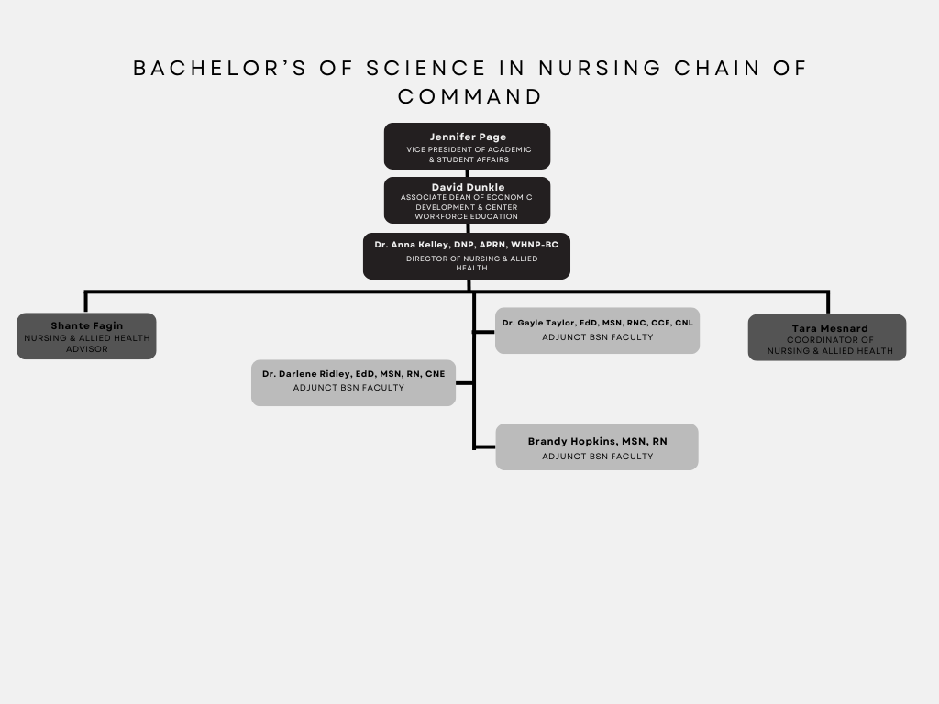
Chain of Command Document
This page is left intentionally blank.

