Website: https://www.nfc.edu/getting-started/admissions/dual-enrollment/sentinel-scholars-collegiate-academy/

SECTION TO UPDATE:
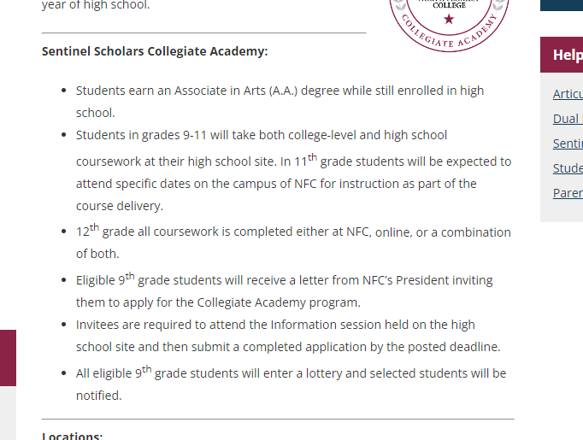

UPDATE the section above with the following:

Sentinel Scholars Collegiate Academy:
- Students earn an Associate in Arts (A.A.) degree while still enrolled in high school.
- Students in grades 10th-11th will take both college-level and high school coursework at their high school site. In 11th grade students will be expected to attend specific dates on the campus of NFC for instruction as part of the course delivery.
- 12th grade all coursework is completed either at NFC, online, or a combination of both.
- Eligible 10th grade students will receive a letter from NFC inviting them to apply for the Collegiate Academy program.
- Invitees are required to attend an information session held on the high school site and then submit a completed application by the posted deadline.
- All eligible 10th grade students will enter a lottery and selected students will be notified.

